Reference Guide
OpenL Mapping Framework
Version 1.1.13

Document number: TP_OpenL_Mapper_RG_1.0_LSh
Revised: 07-12-2017
OpenL Tablets Documentation is licensed under a Creative Commons Attribution 3.0 United States License.

Table of Contents
1 Preface 5
1.1 Related Information 5
1.2 Typographic Conventions 5
2 Introducing the Mapping Framework 6
3 Getting Started 7
4 Field Mapping Algorithm Overview 8
5 Mappings 9
5.1 Rules File Format 9
5.2 Basic Property Mapping 9
Simple Property Mapping 9
Implicit Property Mapping 10
Recursive Mapping 10
Data Type Conversion 10
String to Date Conversion 11
5.3 One Way Mapping 11
5.4 Custom Converters 11
Using the OpenL Tablets Method for Convert Method Definition 12
Rules for Convert Method Definition 12
Using a Static Java Method as a Custom Converter 12
Defining a Custom Converter Class 13
Using a Class Level Custom Converter 13
Custom Converter Search Algorithm 14
5.5 Field Mapping Conditions 14
Using the OpenL Tablets Method to Define a Field Mapping Condition 14
Rules for Field Mapping Condition Definition 15
Using a Static Java Method as a Condition 15
Defining a Custom Condition Class 15
Conditions Search Algorithm 16
5.6 Default Values 16
5.7 Empty Source Mapping 17
5.8 Multi Source Mapping 17
5.9 Index Mapping 17
Simple Index 18
Mapping to the End of Collection 18
Expression Index 18
5.10 Collection Item Discriminator 19
5.11 Deep Mapping 19
Deep Mapping Using the Field Type 20
Using Type Hints for Deep Mapping 20
5.12 Configuration 21
5.13 Configuration Priority 21
5.14 Custom Bean Factories 22
5.15 Create Method 22
5.16 Mapping Inheritance 22
Introducing Super Class Mapping 23
Overriding Super Mapping Definition 23
5.17 Context Based Mapping 24
Mapping Parameters 24
Mapping ID 25
6 Appendix A: Mapping Bean Fields 26
7 Appendix B: ClassMappingConfiguration Bean Fields 28
8 Appendix C: GlobalConfiguration Bean Fields 29
9 Appendix D: Converter Bean Fields 30
10 Appendix E: Date and Time Format 31

Preface
This preface is an introduction to the OpenL Mapping Framework Reference Guide.
The following topics are included in this preface:
- Related Information
- Typographic Conventions

Related Information
The following table lists sources of information related to contents of this guide:
Related information
Title | Description
[OpenL Tablets Reference Guide] | Document that provides overview of the OpenL Tablets technology, its basic concepts, and principles.
http://dozer.sourceforge.net/ | Dozer framework home page.
http://openl-tablets.sourceforge.net/ | OpenL Tablets home page.
http://openl-tablets.sourceforge.net/mapper | Mapper home page.

Typographic Conventions
The following styles and conventions are used in this guide:
Typographic styles and conventions
Convention | Description
Bold | - Represents user interface items such as check boxes, command buttons, dialog boxes, drop-down list values, field names, menu commands, menus, option buttons, perspectives, tabs, tooltip labels, tree elements, views, and windows.  - Represents keys, such as F9 or CTRL+A.  - Represents a term the first time it is defined.
Courier | Represents file and directory names, code, system messages, and command-line commands.
Courier Bold | Represents emphasized text in code.
Select File > Save As | Represents a command to perform, such as opening the File menu and selecting Save As.
Italic | - Represents any information to be entered in a field.  - Represents documentation titles.
< > | Represents placeholder values to be substituted with user specific values.
Hyperlink | Represents a hyperlink. Clicking a hyperlink displays the information topic or external source.
[name of guide] | Reference to another guide that contains additional information on a specific feature.

Introducing the Mapping Framework
A mapping framework (MF) recursively copies data from one object to another. Typically, these data objects are of different complex types.
MF is built using the Dozer framework with several changes as a mapping engine, and OpenL Rules Tablets framework as a tool which provides a convenient mechanism to define conversion rules in declarative way.
The following picture demonstrates the framework lifecycle and displays how underlying frameworks are used by mapper.
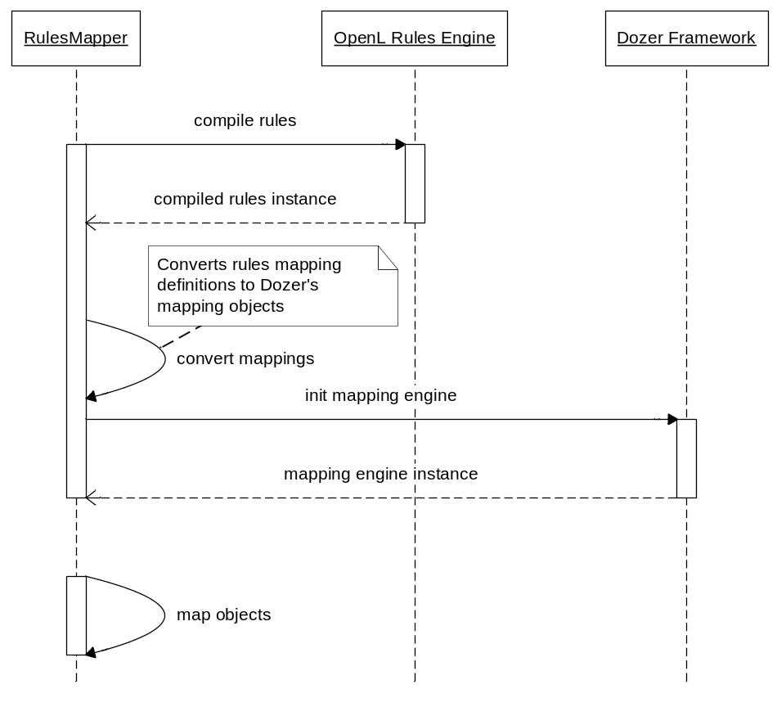
Figure 1: Mapper lifecycle sequence diagram
The mapper is used any time when one type of Java Bean must be taken and mapped to another type of Java Bean. Most field mappings can be done automatically by mapper using reflection.
MF supports simple property mapping, complex type mapping, bi-directional mapping, implicit-explicit mapping, as well as recursive mapping. This includes mapping collection attributes that also need mapping at the element level.

Getting Started
Proceed as follows:
- Add the following dependency to the project’s pom:
<dependency>
<groupId>org.openl.rules</groupId>
<artifactId>org.openl.rules.mapping.dev</artifactId>
<version>1.0.0</version>
</dependency>
- Create mapping rules in Excel file, for example:
Data Mapping mappings
classA | classB | fieldA | fieldB
Class A | Class B | Field A | Field B
Source | Destination | aStringField | aStringField
Source | Destination | anIntegerField | anIntegerField
Figure 2: Mapping definition
- Define one more table:
Environment
import | org.openl.rules.mapping
import | source.package
import | destination.package
Figure 3: Import definition
source.package and destination.package are packages containing Source and Destination classes.
- If necessary, define full Java class names.
Examples of class names are source.package.Source and destination.package.Destination.
- Add the following code snippet to the code to use mapper:
File mappingRules= new File("mapping.xlsx");
Mapper mapper = RulesBeanMapperFactory.createMapperInstance(mappingRules);

Source sourceInstance = new Source();
sourceInstance.setAStringField("string");
sourceInstance.setAnIntegerField(10);

Destination destinationInstance = mapper.map(sourceInstance, Destination.class);
When mapping is completed, a new instance of the destination.package.Destination class is returned with following fields values: “string” for aStringField field and 10 for anIntegerField.

Field Mapping Algorithm Overview
The following picture illustrates algorithm which is used during field mapping:
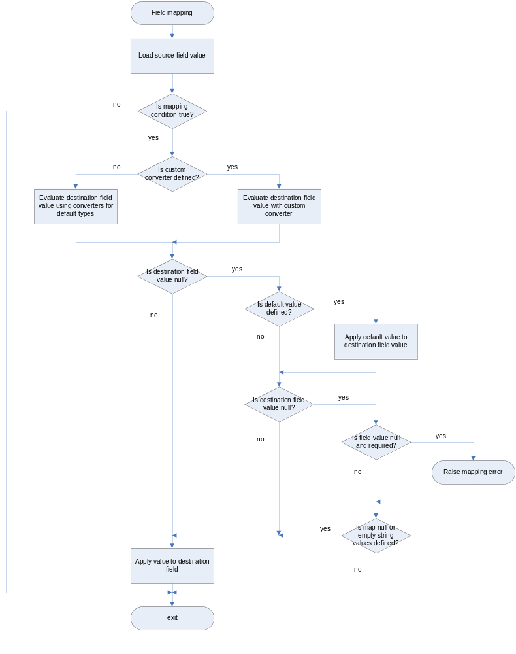
Figure 4: Single field mapping algorithm

Mappings
This chapter describes mappings and includes the following topics:
- Rules File Format
- Basic Property Mapping
- One Way Mapping
- Custom Converters
- Field Mapping Conditions
- Default Values
- Empty Source Mapping
- Multi Source Mapping
- Index Mapping
- Collection Item Discriminator
- Deep Mapping
- Configuration
- Configuration Priority
- Custom Bean Factories
- Create Method
- Mapping Inheritance
- Context Based Mapping

Rules File Format
Mapping file is a valid OpenL Tablets rules file. It must contain tables with all required mapping configuration and custom converter implementation.

Basic Property Mapping
This section describes basic property mapping and includes the following topics:
- Simple Property Mapping
- Implicit Property Mapping
- Recursive Mapping
- Data Type Conversion
- String to Date Conversion

Simple Property Mapping
To map srcField of the source.package.Source class into destField of the destination.package.Destination class, provide a mapping rule such as the following one:
Data Mapping mappings
classA | classB | fieldA | fieldB
Class A | Class B | Field A | Field B
source.package.Source | destination.package.Destination | srcField | destField
Figure 5: Simple property mapping
To map destField of the destination.package.Destination class into srcField of source.package.Source class, do not define a new mapping rule because all mappings are bi-directional by default.

Implicit Property Mapping
By default, mapping framework maps properties with matching names. For example, a source object has a field with a name myField and a destination object has a matching field myField. In this case, the mapping framework performs mapping for these fields automatically. To change the behavior of this feature, use the wildcard configuration parameter as described in Configuration.

Recursive Mapping
The mapping framework supports full class level mapping recursion. For any complex types defined at the field level mappings in the object, the mapping processor will search the mappings for a class level mapping between the two mapped classes. If no mappings are found, the processor only maps fields of the same name between the complex types.

Data Type Conversion
Data type conversion is performed automatically by the mapping engine. The following types of bi-directional conversions are supported:
- PrimitivetoPrimitiveWrapper
- PrimitivetoCustomWrapper
- PrimitiveWrappertoPrimitiveWrapper
- PrimitivetoPrimitive
- ComplexTypetoComplexType
- StringtoPrimitive
- StringtoPrimitiveWrapper
- String to Complex Type if the Complex Type contains a String constructor
- StringtoMap
- CollectiontoCollection
- CollectiontoArray
- MaptoComplexType
- MaptoCustomMapType
- EnumtoEnum
The following data types can be mapped to each other:
- java.util.Date
- java.sql.Date
- java.sql.Time
- java.sql.Timestamp
- java.util.Calendar
- java.util.GregorianCalendar
String can be mapped to any of the supported Date/Calendar objects.
Objects containing the toString() method that produces a long representing time in milliseconds can be mapped to any supported Date/Calendar object.

String to Date Conversion
A date format for the String can be specified at the field level so that the necessary data type conversion can be performed.
Data Mapping mappings
classA | classB | fieldA | fieldB | fieldADateFormat
ClassA | ClassB | FieldA | FieldB | Field A Date Format
Source | Destination | stringField | dateField | yyyy-MM-dd
Figure 6: Date format configuration at the field level
To define the date format at the class level and global level, use the dateFormat configuration parameter as described in Configuration.

One Way Mapping
To map a field pair in one way only, set it at the field level using oneWay parameter.
Data Mapping mappings
classA | classB | fieldA | fieldB | oneWay
Class A | Class B | Field A | Field B | Is one way?
Source | Destination | srcField | destField | true
Figure 7: One way mapping definition
If a one-way mapping is specified, mapping from destField into srcField is ignored.

Custom Converters
Custom converters are used to perform custom mapping between two objects. When a custom converter is specified for a class A and class B combination, the mapper invokes the custom converter to perform the data mapping instead of the standard mapping logic. A custom converter can be defined in different ways.
The following topics are included in this section:
- Using the OpenL Tablets Method for Convert Method Definition
- Rules for Convert Method Definition
- Using a Static Java Method as a Custom Converter
- Defining a Custom Converter Class
- Using a Class Level Custom Converter
- Custom Converter Search Algorithm

Using the OpenL Tablets Method for Convert Method Definition
The following table describes how to define a convert method using the OpenL Tablets method.
Data Mapping mappings
classA | classB | fieldA | fieldB | convertMethodAB
Class A | Class B | Field A | Field B | Convert method ( a into b)
Source | Destination | srcField | destField | typeCdLookup
Figure 8: Convert method definition using the OpenL Tablets method
The convertMethodAB parameter tells the mapper that the typeCdLookup convert method must be used for the current field pair. The following table describes the convert method defined using the OpenL Tablets rules table component:
Rules String typeCdLookup(String key, String dest)
C1 | RET
key
String
Codes | Values
HOME | 03
CO | 06
TE | 04
 | =error ("No PolicyTypeCd lookup for key " + key); ""
Figure 9: Custom converter definition using the OpenL Tablets component
For more information on defining a convert method using the OpenL Tables rule table component, see [OpenL Tablets Reference Guide].

Rules for Convert Method Definition
The following rules apply to the convert methods definition:
- A method has the same name as defined by convertMethodAB parameter.
- A method provides two parameters; the first one is assignable from the source field type, and the second one is assignable from the destination field type.
- The destination field must be assignable from the method return type.
The convert method cannot be used during reverse mapping. To map from a field B into a field A, provide the appropriate convert method using the convertMethodBA parameter.

Using a Static Java Method as a Custom Converter
To use a static Java method as a convert method, provide a class name and a method name.
For example, utils.ConverterUtils.typeCdLookup or ConverterUtils.typeCdLookup (if the second example is used, define the utils package in the import section of the Environment table).
Data Mapping mappings
classA | classB | fieldA | fieldB | convertMethodAB
Class A | Class B | Field A | Field B | Convert method (a into b)
Source | Destination | srcField | destField | ConverterUtils.typeCdLookup
Figure 10: Convert method definition using the Java static method

Defining a Custom Converter Class
For more advanced functionality, define a custom converter implementation class. In this case, implement the org.dozer.CustomConverter interface in order for the mapper to accept it; otherwise, an exception is thrown.
public interface CustomConverter {

Object convert(Object existingDestinationFieldValue,
Object sourceFieldValue,
Class<?> destinationClass,
Class<?> sourceClass);

}
Note: Custom converters get invoked even when the source value is null, so the null values in the custom converter implementation must be handled explicitly.
When the custom converter implementation is created, register it for usage in mapper. An example is as follows:
Map<String, CustomConverter> converters =
new HashMap<String, CustomConverter>();

converters.put("isExists", new CustomConverter(){
public Object convert(Object existingDestinationFieldValue,
Object sourceFieldValue,
Class<?> destinationClass,
Class<?> sourceClass) {
return sourceFieldValue != null;
}
});

File source = new File("CustomConvertersWithIdTest.xlsx");
Mapper mapper = RulesBeanMapperFactory.createMapperInstance(source, converters, null);
…
The following mapping demonstrates how a custom converter can be referenced by ID from the registry of custom converters:
Data Mapping mappings
classA | classB | fieldA | fieldB | convertMethodABId
Class A | Class B | Field A | Field B | Convert method (a into b)
Source | Destination | srcField | destField | isExists
Figure 11: Convert method definition by converter ID

Using a Class Level Custom Converter
Custom converters can be defined at the class level.
Data Converter defaultConverters
classA | classB | convertMethod
Class A | Class B | Convert method
Source | Destination | ConverterUtils.typeCdLookup
Figure 12: Default custom converters definition
Defined default converter is used by a mapping processor when an appropriate class pair must be mapped but the custom converter at the field level is not defined.

Custom Converter Search Algorithm
Mapper uses the following order to find appropriate converter:
- Get a custom converter by its ID.
- Get a custom converter by name, using either a rule or a Java method.
- Get a default custom converter.

Field Mapping Conditions
Field mapping conditions are used at runtime to decide whether field mapping must be executed. When a field mapping condition is specified for a field A and field B combination, a mapper invokes it at the start of field mapping flow as described in Field Mapping Algorithm Overview.
Mapping conditions can be defined in different ways.
The following topics are included in this section:
- Using the OpenL Tablets Method to Define a Field Mapping Condition
- Rules for Field Mapping Condition Definition
- Using a Static Java Method as a Condition
- Defining a Custom Condition Class
- Conditions Search Algorithm

Using the OpenL Tablets Method to Define a Field Mapping Condition
The following table describes how to define a field mapping condition using the OpenL Tablets method.
Data Mapping mappings
classA | classB | fieldA | fieldB | conditionAB
Class A | Class B | Field A | Field B | Map field ( a into b)
Source | Destination | srcField | destField | mapField
Figure 13: Field mapping condition method definition using the OpenL Tablets method
The conditionAB parameter tells to mapper that for the current field pair mapping, the mapField method must be invoked to make a decision. If the method result is true, the mapper executes mapping rule; otherwise, it skips the rule.
An example of condition method definition using OpenL Tablets method table component is as follows:
Method boolean mapField(Object src, Object dest)
return src != null;
Figure 14: Field mapping condition example
For more information on defining a convert method using the OpenL Tables rule table component, see [OpenL Tablets Reference Guide].

Rules for Field Mapping Condition Definition
The following rules apply to the convert methods definition:
- A method has the same name as defined by the conditionAB parameter.
- A method provides two parameters; the first one assignable from the source field type, and the second one assignable from the destination field type.
- A method return type must be of the Boolean type.
The condition method is not used during reverse mapping. To use the condition during mapping from field B into field A, provide an appropriate method using the conditionBA parameter.

Using a Static Java Method as a Condition
To use a static Java method as a condition method, provide a class name and a method name.
For example, utils.ConditionUtils.mapField or ConditionUtils.mapField (if the second example is used, define the utils package in the import section of the Environment table).
Data Mapping mappings
classA | classB | fieldA | fieldB | conditionAB
Class A | Class B | Field A | Field B | Condition method (a into b)
Source | Destination | srcField | destField | ConditionUtils.mapUtils
Figure 15: Condition method definition using a Java static method

Defining a Custom Condition Class
To define a custom field mapping condition implementation class, implement the org.dozer.FieldMappingCondition interface for the mapper to accept it. Otherwise, an exception will be thrown.
public interface FieldMappingCondition {

boolean mapField(Object sourceFieldValue,
Object destFieldValue,
Class<?> sourceType,
Class<?> destType);
}
Note: A field mapping condition gets invoked even when the source value is null, so the null values must be explicitly handled in the implementation.
When the implementation is created, register it for usage in mapper. An example is as follows:
Map<String, FieldMappingCondition> conditions =
new HashMap<String, FieldMappingCondition>();
conditions.put("mapField", new FieldMappingCondition() {

public boolean mapField(Object sourceFieldValue,
Object destFieldValue,
Class<?> sourceType,
Class<?> destType) {
return sourceFieldValue !=null;
}
});

File source = new File("FieldMappingConditionsWithIdTest.xlsx");
Mapper mapper = RulesBeanMapperFactory.createMapperInstance(source, null, conditions);
…
The following mapping illustrates how a condition can be referenced by ID from the conditions registry:
Data Mapping mappings
classA | classB | fieldA | fieldB | conditionABId
Class A | Class B | Field A | Field B | Condition method (a into b)
Source | Destination | srcField | destField | mapField
Figure 16: Condition method definition by ID

Conditions Search Algorithm
The mapper uses the following order to find the appropriate field condition:
- Get a condition by its ID.
- Get a condition by name, using either a rule or a Java method.

Default Values
At the field mapping level, a default value for the destination field can be defined. It will be set into destination property if the source value is null as described in Field Mapping Algorithm Overview.
Data Mapping mappings
classA | classB | fieldA | fieldB | fieldADefaultValue | fieldBDefaultValue
Class A | Class B | Field A | Field B | Field A Default Value | Field B Default Value
Source | Destination | srcField | destField | Some value | Another value
Figure 17: Field default value definition
A default value is a string value which will be converted into field’s type. Currently, the default value string can be converted into the following types:
- primitive types, that is, int, double, short, char, long, Boolean, byte, and float
- wrapper types, that is, java.lang.Integer, java.lang.Double, java.lang.Short, java.lang.Character, java.lang.Long, java.lang.Boolean, java.lang.Byte, and java.lang.Float
- java.math.BigDecimal
- java.math.BigInteger
- java.lang.String
- java.util.Date
- java.util.Calendar
- complex types with a constructor with the java.lang.String parameter provided

Empty Source Mapping
Empty source mapping is a special case of field initialization. Typically empty source mapping is used for constant definition.
Data Mapping mappings
classA | classB | fieldA | fieldB | oneWay | fieldBDefaultValue
Class A | Class B | Field A | Field B | Is one way? | Field B Default Value
Source | Destination |  | destField | true | My constant
Figure 18: Empty source mapping definition
Empty source mapping is always the one-way mapping. It must be ignored during reverse mapping.

Multi Source Mapping
Using multi source mapping is beneficial for data calculation using several sources of input data.
A custom converter must be provided for this type of field mapping.
Data Mapping mappings
classA | classB | fieldA | fieldB | oneWay | convertMethodAB
Class A | Class B | Field A | Field B | Is one way? | Convert method (a into b)
Source1 | Dest | field1 | destField | true | multiSourceFieldConverter
Source1 | Dest | field2 | destField | true | multiSourceFieldConverter
Source1 | Dest | field3 | destField | true | multiSourceFieldConverter
Figure 19: Multi source mapping definition
An array of source field values is used as a value for the convert method first parameter. The second one is the existing destination value.
Method Object multiSourceFieldConverter(Object[] src, Object dest)
String[] result = new String[src.length];

for (inti = 0; i< src.length; i++) {
if (src[i] != null) {
result[i] = src[i].toString();
}
}

return result;
Figure 20: Custom converter for multi source mapping
Multi source mapping is always one-way mapping. It must be ignored during reverse mapping.

Index Mapping
This section describes index mapping. Fields that need to be looked up or written to by indexed property are supported.
The following topics are included in this section:
- Simple Index
- Mapping to the End of Collection
- Expression Index

Simple Index
Mapping using simple index uses the index operator to locate the required element in an array or collection object.
Data Mapping mappings
classA | classB | fieldA | fieldB
Class A | Class B | Field A | Field B
Source | Destination | anArrayField[1] | firstField
Source | Destination | aListField[1] | secondField
Figure 21: Simple index mapping definition
Simple index value is 1-based integer value, that is, index starts with the value 1 and the first element is at 1 index at the array or collection.
Simple index can be used for destination field definition as usually.

Mapping to the End of Collection
Mapping to the end of collection is a special case of simple index and it is defined as a zero index. It can be used to map source data to the destination element and append destination element to the collection. Note that zero is not the index of the last element. Mapping processor creates a new element, maps data to the element, and appends it to the end of collection if this type of index value is used.
Data Mapping mappings
classA | classB | fieldA | fieldB
Class A | Class B | Field A | Field B
Source | Destination | anArrayField[1] | destField[0]
Source | Destination | anArrayField[2] | destField[0]
Figure 22: Mapping to the end of collection
Index of the real element is calculated by mapping processor every time when the zero index appears. This type of index cannot be used for deep mapping definition because the index value is changed at runtime. If it is used in deep mapping, an exception is thrown. It cannot be used for the source field path definition because in this case, a mapper always returns the null value.

Expression Index
The mapper allows defining an expression to look up for an array or collection element. The defined expression must be the JXpath compliant filter expression.
Data Mapping mappings
classA | classB | fieldA | fieldB
Class A | Class B | Field A | Field B
Source | Destination | anArrayField[@name=’John’] | firstField
Figure 23: Expression index mapping definition
The expression index cannot be used for destination field definition. Field mapping, which uses expression index, must be marked as one-way mapping.

Collection Item Discriminator
A collection item discriminator allows defining a destination collection element at runtime when the source object is mapped to the collection or array. For example, the target collection contains list of policies and the collection element representing the required policy is not known. In this case, use the following field mapping definition:
Data Mapping mappings
classA | classB | fieldA | fieldB | fieldBDiscriminator
Class A | Class B | Field A | Field B | Field B Collection Item Discriminator
Source | Destination | array | list | discriminator
Figure 24: Collection item discriminator usage example
The mapping processor maps the collection into collection through the following steps:
- Get the source object or the next element from the source collection.
- Get the target element from the destination collection.
If the collection item discriminator is provided, it is used to get the target element.
- If the target element is not found, for example, discriminator is not defined or discriminator returned a null value, create a new one and add it to the end of the destination collection.
- Map the source element to the target element.
A discriminator can be defined as an OpenL method or as a static Java method. An example is as follows:
Method Object discriminator(Object src, List dest)
// target element resolving goes here …
return null;
Figure 25: Collection item discriminator method example
If the destination field type is an array of primitives, the mapping processor always adds the mapped element as a new one to the end of the array.

Deep Mapping
The mapper can map deep properties. An example is mapping an object with a String property to the other object with a String property that is several levels deep within the object graph.
Data Mapping mappings
classA | classB | fieldA | fieldB
Class A | Class B | Field A | Field B
Source | Destination | srcField.stringField | destField.nestedField.stringField
Figure 26: Deep mapping usage example
The following topics on deep mapping are included in this section:
- Deep Mapping Using the Field Type
- Using Type Hints for Deep Mapping

Deep Mapping Using the Field Type
The field type parameter enables defining the type to be used for the current field.
For example, consider srcField defined as a BaseType type and destField defined as a DestType type. The DestType type is a super type of the CustomType type. At runtime, destField is CustomType value, and the mapper must be told to map srcField into destField as the BaseType value into CustomType value instead of BaseType value into DestType value, because, for example, CustomType value has extra data that must be mapped. In this case, use the fieldBType parameter to define the required type of the field.
Data Mapping mappings
classA | classB | fieldA | fieldB | fieldBType
Class A | Class B | Field A | Field B | Field B Type
Source | Destination | srcField | destField[0] | CustomType
Figure 27: Field type casting example
The field type can be used for destination field and collection elements only.

Using Type Hints for Deep Mapping
The type hints concept is the same as the field type concept but provided for a deep mapping use case.
The field type hints value is an array of class names that will be used as a type of the appropriate field in the defined field path. For more information on array definition, see [OpenL Tablets Reference Guide], section Arrays in OpenL Tablets.
Data Mapping mappings
classA | classB | fieldA | fieldB | fieldBHint
Class A | Class B | Field A | Field B | Field B Hint
Source | Destination | srcField.stringField | destField.nestedField.stringField | DestType, NestedType
Figure 28: Type hints usage example
The field type hints can be simplified to skip the class type definition for the appropriate field in the defined field path.
Data Mapping mappings
classA | classB | fieldA | fieldB | fieldBHint
Class A | Class B | Field A | Field B | Field B Hint
Source | Destination | srcField.stringField | destField.nestedField.stringField | ,NestedType
Figure 29: Simplified type hints definition example
Note that the leading comma is not omitted to keep correspondence between fields and hints. Trailing commas can be omitted, for example, NestedType, , , is equal to NestedType, but NestedType,,,OtherType is not equal to NestedType,OtherType.

Configuration
Configurations are used to set default mapping parameters. By default, the mapper uses the following policies during mapping process:
Mapping default policies
Name | Value | Description
MapNulls | true | Defines whether null values will be skipped or mapped as usually.
MapEmptyStrings | true | Defines whether empty strings will be skipped or mapped as usually.
TrimStrings | false | Defines whether trim operation will be executed on strings.
Fields are required | false | Defines that fields are required and they cannot be null.
Apply wildcard | true | Defines that mapping processor will map matching fields implicitly.
In accordance with business needs, policies can be changed with configuration components. Configuration can be applied at global level and at class level. Configurations are optional.
Data GlobalConfiguration globalConfiguration
mapNulls | trimStrings | mapEmptyStrings | requiredFields | dateFormat | wildcard
Map Nulls | Trim Strings | Map Empty Strings | Fields are required | Date format | Wildcard
FALSE | TRUE | TRUE | FALSE | MM-dd-yyyy | FALSE
Figure 30: Mapping process configuration definition at global level
Global configuration must be the only one defined. If there are several definitions, an exception is thrown.
Data ClassMappingConfiguration classConfiguration
classA | classB | mapNulls | trimStrings | mapEmptyStrings | requiredFields | dateFormat | wildcard
Class A | Class B | Map Nulls | Trim Strings | Map Empty Strings | Fields are required | Date format | Wildcard
A | B | FALSE | TRUE | FALSE | FALSE | MM-dd-yyyy | FALSE
Figure 31: Mapping process configuration definition at class level
Class level configuration will be used by mapper for the specified class pair mapping independent of mapping direction.

Configuration Priority
Mapping processor uses the following order to get the appropriate mapping configuration:
- field level configuration
- class level configuration
- global level configuration
- default mapping policy

Custom Bean Factories
The mapper can be configured to use custom bean factories to create new instances of destination data objects during the mapping process. By default, the mapper only creates a new instance of any destination objects using a default constructor. Specify your own bean factories to instantiate the data objects.
The custom bean factory must implement the org.dozer.BeanFactory interface.
public interface BeanFactory {
Object createBean(Object source,
Class<?> sourceClass,
String targetBeanId);

}
Then update configuration for the target class.
Data ClassMappingConfiguration classConfiguration
classA | classB | classABeanFactory | classBBeanFactory
Class A | Class B | Class A Bean Factory | Class B Bean Factory
A | B | ClassABeanFactory | ClassBBeanFactory
Figure 32: Bean factory usage example
The Dozer framework provides org.dozer.factory.JAXBBeanFactory and org.dozer.factory.XMLBeanFactory classes to support JAXB and XMLBeans objects.

Create Method
The mapper can be configured to use custom static create methods to create new instances of destination data objects during the mapping process.
Data Mapping mappings
classA | classB | fieldA | fieldB | fieldACreateMethod
Class A | Class B | Field A | Field B | Field A Create Method
Source | Destination | srcField | destField | CreateMethodClass.createMethod
Figure 33: Field type casting example
Create method is a java static method with no parameters.
public class CreateMethodClass {

public static CustomType createMethod() {
return new CustomType();
}
}

Mapping Inheritance
This section describes mapping inheritance principles and includes the following topics:
- Introducing Super Class Mapping
- Overriding Super Mapping Definition

Introducing Super Class Mapping
When mapping subclasses with base class attributes, individual mappings for these attributes are not required if they are already defined for super class mapping. For example, consider the following classes:
public class Source {
private String firstField;
private String secondField;

…
}

public class ParentDest {
private String firstField;

…
}

public class ChildDest extends ParentDest {
private String secondField;

…
}
For these classed, define the following mapping:
Data Mapping mappings
classA | classB | fieldA | fieldB
Class A | Class B | Field A | Field B
Source | ParentDest | firstField | firstField
Source | ChildDest | secondField | secondField
Figure 34: Mapping attributes of a parent class
In case of mapping the Source object to ChildDest, the mapping processor uses mappings of the Source-ParentDest class pair to map attributes of the super class, that is, for the previously described example, Source.firstField into ParentDest.firstField.

Overriding Super Mapping Definition
Super mapping definition can be overridden by defining a new field mapping which uses the same field paths and appropriate class pair.
Data Mapping mappings
classA | classB | fieldA | fieldB | convertMethodAB
Class A | Class B | Field A | Field B | Convert Method (a into b)
Source | ParentDest | firstField | firstField
Source | ChildDest | firstField | firstField | customConvertMethod
Figure 35: Overriding mapping attributes of a parent class
In this example, the mapping processor will use the first field mapping definition for the Source and ParentDest classes, and the second one for the Source and ChildDest classes.

Context Based Mapping
This section describes the context based mapping. Mapping ID defines the field mapping definitions to be used by the mapping processor, while mapping parameters define how the appropriate field mappings will be processed.
The following topics are included:
- Mapping Parameters
- Mapping ID

Mapping Parameters
Mapping flow can be changed by a user at runtime using mapping parameters. Mapping parameters can be used by custom converters and field mapping conditions.
Data Mapping mappings
classA | classB | fieldA | fieldB | convertMethodABId
Class A | Class B | Field A | Field B | Convert method (a into b)
Source | Destination | srcField | destField | convertMethodId
Figure 36: Convert method definition by converter ID
When using mapping parameters, provide implementation of the org.dozer.BaseMappingParamsAwareCustomConverter class. BaseMappingParamsAwareCustomConverter defines the extended convert method which must be implemented by user. The following example illustrates how the mapping parameters can be used:
Map<String, CustomConverter> converters =
new HashMap<String, CustomConverter>();
converters.put("convertMethodId", new BaseMappingParamsAwareCustomConverter(){

public Object convert(MappingParameters params,
Object existingDestinationFieldValue,
Object sourceFieldValue,
Class<?> destinationClass,
Class<?> sourceClass) {
return params.get("value");
}
});

File source = new File("mapping.xlsx");
Mapper mapper = RulesBeanMapperFactory.createMapperInstance(source, converters, null);

MappingContext context = new MappingContext();
MappingParameters params = new MappingParameters();
params.put("value", "value1");
context.setParams(params);

Destinationdest = mapper.map(source, Destination.class, context);
…
When using an OpenL method as a custom converter or Java static class, extend the method signature with the org.dozer.MappingParameters formal parameter.
Method Object convertMethod(MappingParameters params, Object src, Object dest)
return params.get(“value”);
Figure 37: Custom converter which uses mapping parameters
The mapping processor uses the following rules to find the appropriate OpenL method or Java static method when using it as a convert method:
- If mapping parameters are defined by user, mapping processor searches for a convert method with extended signature.
If the method is found, the mapper invokes it; otherwise, the mapper searches for a method with usual signature.
- If mapping parameters are not defined by a user, the mapping processor searches for a convert method with usual signature.
The mapping processor uses the same approach for field mapping conditions. When using mapping parameters for field mapping conditions, provide implementation of the org.dozer.BaseMappingParamsAwareFieldMappingCondition class as a condition method.
The mapping framework also provides the org.dozer.factory.BaseMappingParamsAwareBeanFactory class which uses mapping parameters to create bean instances.

Mapping ID
The mapping flow can be changed by using the mapping ID value.
Data Mapping mappings
classA | classB | fieldA | fieldB | convertMethodAB | mapId
Class A | Class B | Field A | Field B | Convert method (a into b) | Mapping ID
Source | Destination | srcField | destField | convertMethod | mappingID
Source | Destination | srcField | destField
Figure 38: Field mapping definitions with mapID parameter
A user can specify which field mapping must be used by the mapping processor. In general case, the mapping processor will use the second definition to map. If the first mapping definition must be used, set the mappingID value to the mapId property of mapping context as follows:
…
MappingContext context = new MappingContext();
context.setMapId("mappingID");
Destination dest = mapper.map(source, Destination.class, context);
…
The mapping processor uses the following rules to define the field mappings to be used:
- If the mapping ID is not specified for the context, get field mapping definitions without mapId value, that is, a general set of field mappings.
- If the mapping ID is specified for context, proceed as follows:
- Get field mapping definitions with the same mapId value as the provided mapping ID.
- Get field mapping definitions without the mapId value which do not define the same field mapping as already selected with the defined mapId value.
Field mapping definitions that are not selected will not be processed at runtime.

Appendix A: Mapping Bean Fields
Mapping definition element fields are described in the following table:
Mapping bean fields
Name | Type | Required | Default value | Description
classA | Class<?> | ✓yes |  | Class name of the first object to map.
classB | Class<?> | ✓yes |  | Class name of the second object to map.
fieldA | String[] | ✓yes |  | Field name of the first object to map.
fieldB | String | ✓yes |  | Field name of the second object to map.
convertMethodAB | String | no |  | OpenL rule used as a convert method or Java class static method.
convertMethodBA | String | no |  | OpenL rule used as a convert method or Java class static method.
convertMethodABId | String | no |  | ID of the convert method.
convertMethodBAId | String | no |  | ID of the convert method.
oneWay | Boolean | no | false | One- or bi-directional mapping.
mapNulls | Boolean | no | true | Null values processing method, which is skipping values or mapping as usually.
mapEmptyStrings | Boolean | no | true | Empty strings processing method, which is skipping values or mapping as usually.
trimStrings | Boolean | no | false | Strings processing method, which identifies whether trim operation will be executed.
fieldACreateMethod | String | no |  | Name of create method to be used to create field A value object instance or Java class static method.
fieldBCreateMethod | String | no |  | Name of create method to be used to create field B value object instance or Java class static method.
fieldADefaultValue | String | no |  | Default value of the field.
fieldBDefaultValue | String | no |  | Default value of the field.
fieldADateFormat | String[] | no |  | Date format string for the field A value.
fieldBDateFormat | String | no |  | Date format string for the field B value.
fieldAHint | Class<?>[][] | no |  | Type hints for the field A used for deep mapping only.
fieldBHint | Class<?>[] | no |  | Type hints for field B used for deep mapping only.
fieldAType | Class<?>[] | no |  | Type of the field A value.
fieldBType | Class<?> | no |  | Type of the field B value.
fieldARequired | Boolean | no | false | Identifier that the field is required and cannot be null.
fieldBRequired | Boolean | no | false | Identifier that the field is required and cannot be null.
conditionAB | String | no |  | OpenL Boolean condition expression identifying whether the current mapping will be used in the mapping process.
conditionBA | String | no |  | OpenL Boolean condition expression identifying whether the current mapping will be used in the mapping process.
conditionABId | String | no |  | ID of the condition method.
conditionBAId | String | no |  | ID of the condition method.
fieldADiscriminator | String | no |  | Discriminator as OpenL rule or Java class static method.
fieldBDiscriminator | String | no |  | Discriminator as OpenL rule or Java class static method.

Appendix B: ClassMappingConfiguration Bean Fields
ClassMappingConfiguration definition element fields are described in the following table:
ClassMappingConfiguration bean fields
Name | Type | Required | Default value | Description
classA | Class<?> | ✓yes |  | Class name of the first object to map.
classB | Class<?> | ✓yes |  | Class name of the second object to map.
classABeanFactory | Class<?> | no |  | Bean factory class.
classBBeanFactory | Class<?> | no |  | Bean factory class.
mapNulls | Boolean | no | true | Null values processing method, which is skipping values or mapping as usually.
mapEmptyStrings | Boolean | no | true | Empty strings processing method, which is skipping values or mapping as usually.
trimStrings | Boolean | no | false | Strings processing method, which identifies whether trim operation will be executed.
requiredFields | Boolean | no | false | Identifier that fields are required and cannot be null.
wildcard | Boolean | no | true | Identifier that the mapping processor will map matching fields implicitly.
dateFormat | String | no |  | Default date format to be used for converting string to date and the opposite way.

Appendix C: GlobalConfiguration Bean Fields
GlobalConfiguration definition element fields are described in the following table:
GlobalConfiguration bean fields
Name | Type | Required | Default value | Description
mapNulls | Boolean | no | true | Null values processing method, which is skipping values or mapping as usually.
mapEmptyStrings | Boolean | no | true | Empty strings processing method, which is skipping values or mapping as usually.
trimStrings | Boolean | no | false | Strings processing method, which identifies whether trim operation will be executed.
requiredFields | Boolean | no | false | Identifier that fields are required and cannot be null.
wildcard | Boolean | no | true | Identifier that the mapping processor will map matching fields implicitly.
dateFormat | String | no |  | Default date format to be used for converting string to date and the opposite way.

Appendix D: Converter Bean Fields
Converter definition element fields are described in the following table:
Converter bean fields
Name | Type | Required | Description
classA | Class<?> | ✓yes | Class name of the first object to map.
classB | Class<?> | ✓yes | Class name of the second object to map.
convertMethod | String | ✓yes | Convert method name.

Appendix E: Date and Time Format
Mapping framework uses the java.text.SimpleDateFormat class to work with dates.
For more information on this class, see http://docs.oracle.com/javase/1.5.0/docs/api/java/text/SimpleDateFormat.html.
Date and time formats are specified by date and time pattern strings. Within date and time pattern strings, unquoted letters from 'A' to 'Z' and from 'a' to 'z' are interpreted as pattern letters representing the components of a date or time string. Text can be quoted using single quotes (') to avoid interpretation. The double quote symbol '' represents a single quote. All other characters are not interpreted and are simply copied into the output string during formatting or matched against the input string during parsing.
The following table describes defined pattern letters, while all other characters from 'A' to 'Z' and from 'a' to 'z' are reserved:
Letter patterns
Letter | Date or Time Component | Presentation | Examples
G | Era designator | Text | AD
y | Year | Year | 1996; 96
M | Month in year | Month | July; Jul; 07
w | Week in year | Number | 27
W | Week in month | Number | 2
D | Day in year | Number | 189
d | Day in month | Number | 10
F | Day of week in month | Number | 2
E | Day in week | Text | Tuesday; Tue
a | Am/pm marker | Text | PM
H | Hour in day (0-23) | Number | 0
k | Hour in day (1-24) | Number | 24
K | Hour in am/pm (0-11) | Number | 0
h | Hour in am/pm (1-12) | Number | 12
m | Minute in hour | Number | 30
s | Second in minute | Number | 55
S | Millisecond | Number | 978
z | Timezone | General timezone | Pacific Standard Time; PST; GMT-08:00
Z | Timezone | RFC 822 timezone | -0800
Pattern letters are usually repeated, as their number determines the exact presentation:
- Text: For formatting, if the number of pattern letters is 4 or more, the full form is used; otherwise a short or abbreviated form is used if available. For parsing, both forms are accepted, independent of the number of pattern letters.
- Number: For formatting, the number of pattern letters is the minimum number of digits, and shorter numbers are zero-padded to this amount. For parsing, the number of pattern letters is ignored unless it is required to separate two adjacent fields.
- Year: For formatting, if the number of pattern letters is 2, the year is truncated to 2 digits; otherwise it is interpreted as number.
For parsing, if the number of pattern letters is more than 2, the year is interpreted literally, regardless of the number of digits. So using the pattern "MM/dd/yyyy", "01/11/12" parses to Jan 11, 12 A.D.
The following examples display how date and time patterns are interpreted in the U.S. locale. The given date and time are 2001-07-04 12:08:56 local time in the U.S. Pacific time zone.
Patterns usage examples
Date and Time Pattern | Result
"yyyy.MM.dd G 'at' HH:mm:ss z" | 2001.07.04 AD at 12:08:56 PDT
"EEE, MMM d, ''yy" | Wed, Jul 4, '01
"h:mm a" | 12:08 PM
"hh 'o''clock' a, zzzz" | 12 o'clock PM, Pacific Daylight Time
"K:mm a, z" | 0:08 PM, PDT
"yyyyy.MMMMM.dd GGG hh:mmaaa" | 02001.July.04 AD 12:08 PM
"EEE, dMMMyyyyHH:mm:ssZ" | Wed, 4 Jul 2001 12:08:56 -0700
"yyMMddHHmmssZ" | 010704120856-0700

